Rational Unified Process Methodology

is shortly known as an [RUP is a one modern software development process](https://www.toolshero.com/information-technology/rational-unified-process-rup/). This methodology divides the development process into four distinct phases that each involves business modeling, analysis and design, implementation, testing, and deployment. This is an object-oriented and web-enabled program development methodology. Which considering the project in hand I considered rapidly that will be suitable, therefore after checking what other benefits can the methodology offer came across This model also helps software developer for providing them guidelines, templates, and examples for all aspects and stages of software development.

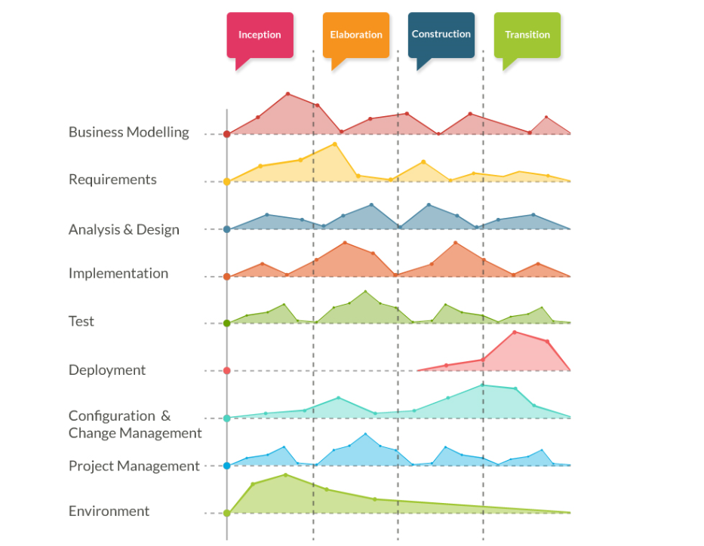

Having a look at figure 1 there are more phases than the ones mentioned first hand. look at them as sort of complementary phases or subphases for the ones mentioned before as well as a allowing project managers and business analyst to explained and plan guidelines and aspects of the stages of the software development.

**Advantages of RUP Software Development Methodology:**

* This methodology emphasizes on accurate documentation
* It is proactively able to resolve the project risks that are associated with the clients evolving requirements for careful changes and request management
* Very less need for integration as the process of integration goes on throughout the development process

**Disadvantages of RUP Software Development Methodology:**

* The software developer needs to be expert in their work to develop software under this methodology.
* The development process in this methodology is very complex and not exactly organized.
* Integration throughout the process of software development adds the confusion that causes more issues during the stages of testing.
* This process is too complex therefore it is very hard to understand.